**Disciplined Entrepreneurship Workbook**

# Step 14: Estimate the Total Addressable Market Size for Follow-on Markets

## Worksheet

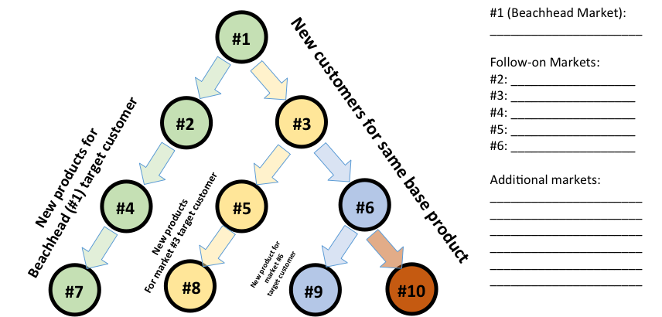

**Beachhead Market**

**#1:**  Early Adopter Academic Researchers using AI tools

**Follow-on Markets:**

**#2:** Advanced Data Visualization Suite for AI Co-Scientist Users (New Product for Beachhead Customer)

**#3:** Industry Researchers (AI/ML Focused) (New Customer for Same Product - e.g., Dr. Rossi, Dr. Sharma)

**#4:** Educational Module/Platform based on AI Co-Scientist (New Product for Beachhead Customer type/setting)

**#5:**  Enterprise AI Co-Scientist (Enhanced Security & Integration) (New Product for Market #3 Customer)

**#6:** Government & Non-Profit Researchers (New Customer for Same Product - potential fit for climate/ethics researchers like Dr. Carter, Dr. Jones)

**Additional Markets:**

* Later Adopter Academic Researchers (Majority of the academic market from Step 4)
* Researchers in less computationally intensive fields (Social Sciences, Humanities) adapting the tool.
* Undergraduate Research Programs (Extension of #4).
* Technical Consulting Firms.
* Citizen Scientists / Independent Researchers.
* Specialized AI Agent Add-on Packs (e.g., Drug Discovery, Climate Modeling agents based on Step 9 examples).

|  |  |  |  |  |  |  |  |  |
| --- | --- | --- | --- | --- | --- | --- | --- | --- |
| Summary of Follow-on TAM Estimate and Priorities | | | | | | | | |
|  | **Candidate** | **How it Leverages Your Core** | **Same Product or Same Customer?** | **Pros of Selling to This Market** | **Cons of Selling to This Market** | **TAM Est.** | **Other Considerations** | **Rank** |
|  | **#3: Industry Researchers (AI/ML Focused)** | Directly uses Core AI; Industry data enriches Core's learning. | Same Product, New Customer | Large potential market, higher potential revenue/user, diversifies income, validates value beyond academia. | Different sales cycle, specific feature needs (security, integration), potentially stronger niche competitors. | €200M - €1.2B | Similar profitability to Beachhead possible (10-30% Step 4). Longer sales cycle (Step 13). Needs validation for enterprise features (leads to #5). High potential. | **1** |
|  | **#6: Government & Non-Profit Researchers** | Directly uses Core AI; Data from different research types enriches Core learning. | Same Product, New Customer | Stable funding possible, addresses different impactful research areas (climate, ethics), potentially less competition. | Bureaucratic hurdles, slower adoption cycles, specific compliance/reporting needs, potentially lower budget flexibility. | €60M - €600M | Profitability likely similar. Time to conquer may be slow due to bureaucracy. DMU (Step 12) might be complex. Moderate potential. | **2** |
|  | **#5: Enterprise AI Co-Scientist (Enhanced Security etc.)** | Core AI is central; adds layers needed for enterprise adoption. | New Product, New Customer (#3) | Addresses specific high-value needs of industry (#3), commands premium price, deepens relationship with industry segment. | Requires significant new development (enterprise features), longer/complex sales cycle, dedicated enterprise sales/support needed. | €150M - €1B | Higher revenue/user could mean higher profitability %. Significant investment required. Builds on success in #3. High potential but requires maturity. | **3** |
|  | **#2: Advanced Data Visualization Suite** | Leverages outputs & user base of Core product; enhances perceived value of Core AI. | New Product, Same Customer (#1) | Sell more to existing happy customers, leverages established relationships, relatively easy market entry point. | Requires new product development, potential distraction from Core AI focus, smaller market size than new customer segments. | €12M - €72M | Potentially lower margin than Core software? Faster time to market than new customer segments. Lower overall potential but easier entry. | **4** |
|  | **#4: Educational Module/Platform** | Leverages Core product as a teaching tool; indirectly showcases Core capabilities. | New Product, Same Customer (#1) | Large potential user base (students), builds brand early with next generation, supports academic mission. | Different buyer (universities/educators), likely lower price point/user, requires different features & support model. | €10M - €120M | Likely lower profitability due to educational pricing. Different sales model needed. Strategic value in building future user base. Lower immediate potential. | **5** |

|  |  |  |  |  |
| --- | --- | --- | --- | --- |
| Individual Worksheet for Each Follow-on Market Segment - #2 | | | | |
| **Follow-on Market Segment Candidate Name:** Advanced Data Visualization Suite for AI Co-Scientist Users | | | | |
| **Estimate # of Users** | **Estimate Revenue per year per user** | **Estimate TAM Range** | **Compound Annual Growth Rate (CAGR)**  **Estimate** | **Other Considerations (profitability, time to conquer, potential market share, investment required, competition, etc.) and Other Comments** |
| 120,000 - 240,000 (Assuming 20-40% uptake from Beachhead #1 users of 600k) | €100 - €300 (Add-on pricing) | €12M - €72M | 25-30% (Riding on growth of core AI tool adoption) | **Profitability:** Potentially lower margin than core software. **Time:** Relatively fast to market to existing users. **Market Share:** Could capture a good share of the base users if integrated well. **Investment:** Moderate R&D for new features. **Competition:** Existing standalone viz tools. **Comments:** Good way to increase revenue per existing customer. Leverages trust but requires dedicated product effort outside the core AI |

|  |  |  |  |  |
| --- | --- | --- | --- | --- |
| Individual Worksheet for Each Follow-on Market Segment - #3 | | | | |
| **Follow-on Market Segment Candidate Name:**  Industry Researchers (AI/ML Focused) | | | | |
| **Estimate # of Users** | **Estimate Revenue per year per user** | **Estimate TAM Range** | **CAGR**  **Estimate** | **Other Considerations (profitability, time to conquer, potential market share, investment required, competition, etc.) and Other Comments** |
| 400,000 - 800,000 (Estimate based on global industry R&D, needs external validation) | €500 - €1500 (Higher budgets/value perception than academia) | €200M - €1.2B | 30-35% (AI adoption in industry likely very strong) | **Profitability:** Similar to Beachhead (10-30%) possible, maybe higher. **Time:** Longer sales cycle (Step 13), takes time to build trust/validate. **Market Share:** Aim for 10-20% initially. **Investment:** Sales/marketing adaptation, minor feature tweaks (leads to #5). **Competition:** Established industry players, internal tools, other AI startups (Step 11). **Comments:** Natural adjacency. High potential. Needs focus on reliability, security, ROI (based on Step 9 feedback from Dr. Rossi/Sharma). |

|  |  |  |  |  |
| --- | --- | --- | --- | --- |
| Individual Worksheet for Each Follow-on Market Segment - #4 | | | | |
| **Follow-on Market Segment Candidate Name:**  Educational Module/Platform based on AI Co-Scientist | | | | |
| **Estimate # of Users** | **Estimate Revenue per year per user** | **Estimate TAM Range** | **CAGR**  **Estimate** | **Other Considerations (profitability, time to conquer, potential market share, investment required, competition, etc.) and Other Comments** |
| 200,000 - 600,000 (Effective licensed users via institutions/courses; potentially millions of actual student users) | €50 - €200 (Likely institutional site licenses or per-course fees) | €10M - €120M | 20-25% (EdTech adoption can be slower) | **Profitability:** Likely lower margins due to educational pricing. **Time:** Slow adoption cycles in universities. **Market Share:** Dependent on partnerships & curriculum integration. **Investment:** Requires curriculum development, different UI/UX for students, teacher support materials. **Competition:** Existing educational software, universities' internal platforms. **Comments:** Strategic long-term play for brand building and future user acquisition, but different business model. |

|  |  |  |  |  |
| --- | --- | --- | --- | --- |
| Individual Worksheet for Each Follow On Market Segment - #5 | | | | |
| **Follow-on Market Segment Candidate Name:** Enterprise AI Co-Scientist (Enhanced Security & Integration) | | | | |
| **Estimate # of Users** | **Estimate Revenue per year per user** | **Estimate TAM Range** | **CAGR**  **Estimate** | **Other Considerations (profitability, time to conquer, potential market share, investment required, competition, etc.) and Other Comments** |
| 150,000 - 400,000 (Assuming 30-50% of Market #3 needs/pays for premium features) | €1000 - €2500 (Premium enterprise pricing) | €150M - €1B | 30-40% (High growth for enterprise-grade AI solutions) | **Profitability:** Potentially higher margins due to premium pricing. **Time:** Long sales cycles, requires proving value in pilot projects. **Market Share:** Capture a fraction of #3 initially. **Investment:** Significant R&D for security, compliance, MLOps integration (Step 9 feedback), dedicated enterprise sales/support team. **Competition:** Major cloud AI platforms, specialized enterprise AI vendors. **Comments:** High-value segment, builds on success in #3. Requires significant company maturity and resources. Key focus on reliability, scalability, security, integration. |

|  |  |  |  |  |
| --- | --- | --- | --- | --- |
| Individual Worksheet for Each Follow On Market Segment - #6 | | | | |
| **Follow-on Market Segment Candidate Name:** Government & Non-Profit Researchers | | | | |
| **Estimate # of Users** | **Estimate Revenue per year per user** | **Estimate TAM Range** | **CAGR**  **Estimate** | **Other Considerations (profitability, time to conquer, potential market share, investment required, competition, etc.) and Other Comments** |
| 200,000 - 500,000 (Estimate based on global research institutes, needs validation) | €300 - €1200 (Similar to academia, maybe slightly higher funded) | €60M - €600M | 25-30% (Steady adoption, potentially slower than industry) | **Profitability:** Similar to Beachhead likely. **Time:** Can be slow due to procurement rules and bureaucracy (Step 13). **Market Share:** Potential for strong share if specific needs are met. **Investment:** Adapt marketing, potentially add compliance features. **Competition:** May be less intense than industry? Depends on research area. **Comments:** Different research focus can enrich the Core AI's learning. Requires patience with sales/adoption process. DMU may be complex. |